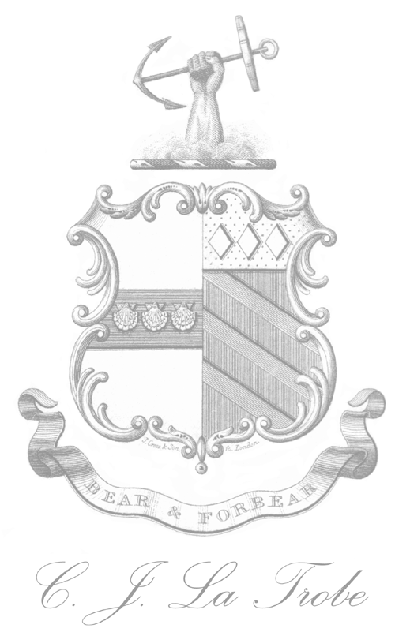
Cover Sheet for Contributors to La Trobeana

Please email this with your article to
secretary@latrobesociety.org.au

Author’s Name and Title

Title of article

Postal address

Telephone
Email address
Brief Biographical note on author
(70-100 words)

Word length
Brief Abstract
(up to 100 words)

Number of
suggested images
Suggested captions

Any special comments

